**BAHRIA UNIVERSITY (KARACHI CAMPUS**)

Assignment 2

Formal methods in software engineering

Class: **(BSE 5A/5B)**

Course Instructor: **(FAIZ UL HAQUE ZEYA)** Max Marks:5

Due date: 2/12/2022

Student’s Name: M Muaz Shahzad Reg. No: 02-131202-081



<https://lms.bahria.edu.pk/Teacher/Quizzes.php?r=successAddQuiz>

**CLO 2**

1. Design the table using Z. ( 2 marks)

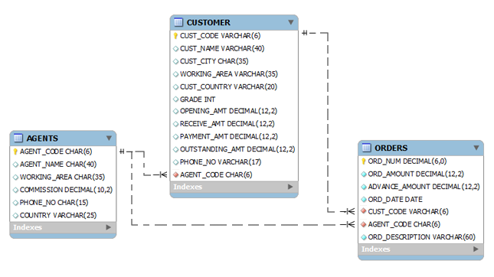

1. Design the pair in Z of name and NIC no. ( 2 marks)

Write queries for the following.

Find NIC no of names {Fahad,Asad,Akif}

Find name of person with NIC between{44233000} and {44234000}

1. Write three operational schiema of any space craft functionality ( 1 mark)



